Electronic Records Committee
Tip Sheet
Document Management Systems vs. Digital Preservation Systems

Introduction
While there are similarities between electronic document management systems and digital preservation systems, they work at different stages of the records life-cycle. A document management system governs the creation, editing and use of active records for the duration of their retention period. A digital preservation system maintains records after they are no longer actively used but need to be retained long-term for their historical value.
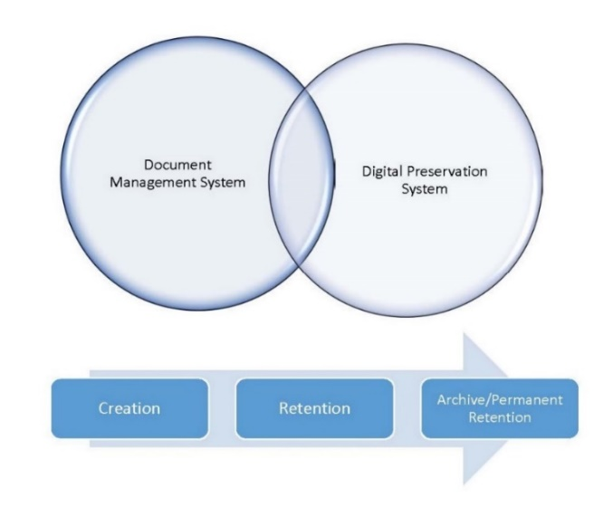
Records Life-Cycle Functions
As a result, document management systems and digital preservation systems focus on different functions within the life-cycle of records. As the following diagrams show, document management systems have the closest connection to those functions involving active records, such as creating, editing and sharing records as well as retaining and disposing of records per their retention schedules. Digital preservation systems will not be used to create records nor will they be focused on retaining and disposing of records according to retention schedules. Rather their focus is on the long-term storage of permanent records. Some digital preservation systems may also include a component of providing public access to the records.

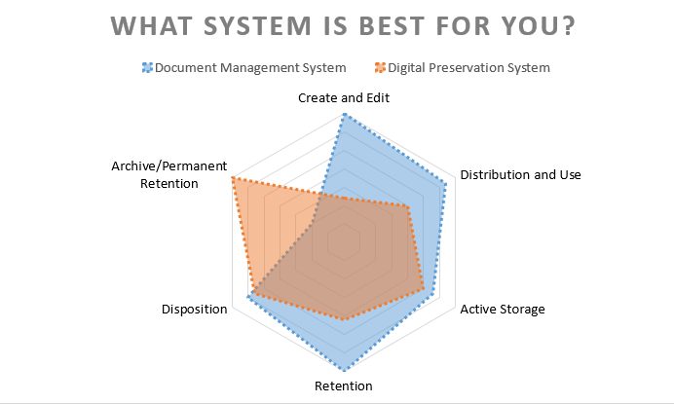
Features of Digital Preservation
While most records of an office don’t have historical value, those digital records that do require a proactive approach to preservation. The Open Archival Information System (OAIS) Reference Model (ISO 14721) provides a framework for digital preservation, including:
- Verifying receipt of the records when they are transferred.
- Establishing the authenticity of the records at the time of transfer through checksums.
- Checking the records for viruses.
- Addressing hardware and software obsolescence through migrations.
- Recording descriptive and preservation metadata, including allowing various schemas to fit organizational needs.
- Converting records to open formats or generally accepted long-term formats based on archival standards and best practices to prevent format obsolescence and to facilitate public access to the records.
- Maintaining the integrity of the records and protecting against degradation/corruption of formats or software by monitoring the fixity of the records.
- Documenting the chain of custody and any changes made to the records.
These actions should be kept in mind when evaluating systems for digital preservation.
OhioERC.org

